# CS 255 System Design Document Template

## UML Diagrams

### UML Use Case Diagram

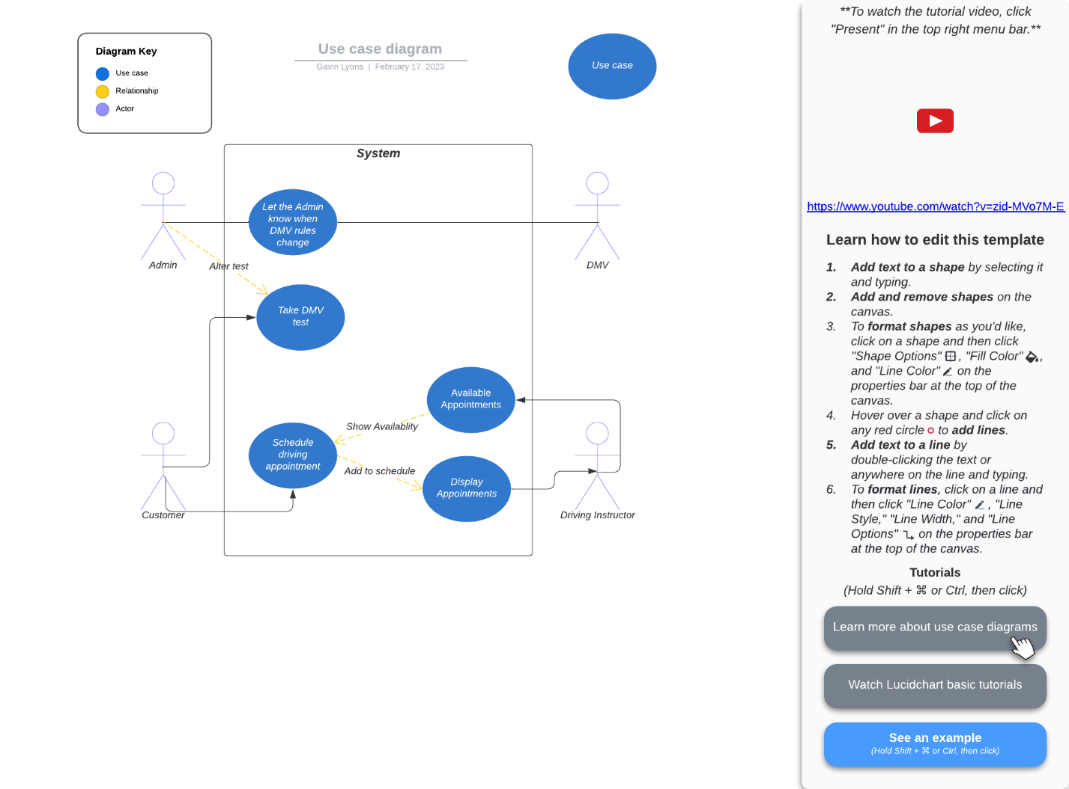

### UML Activity Diagrams

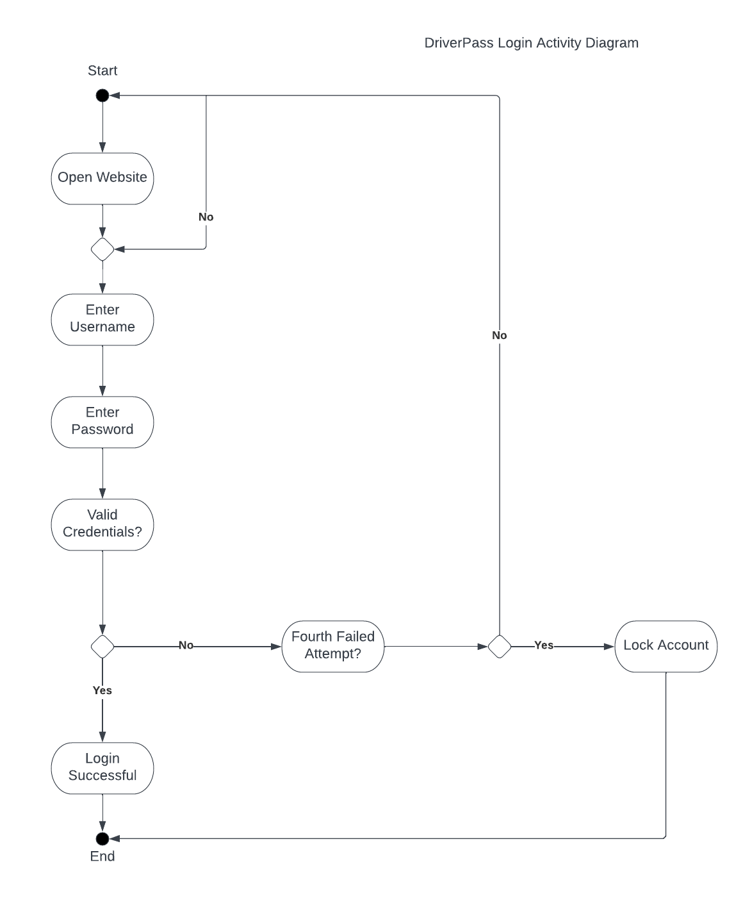

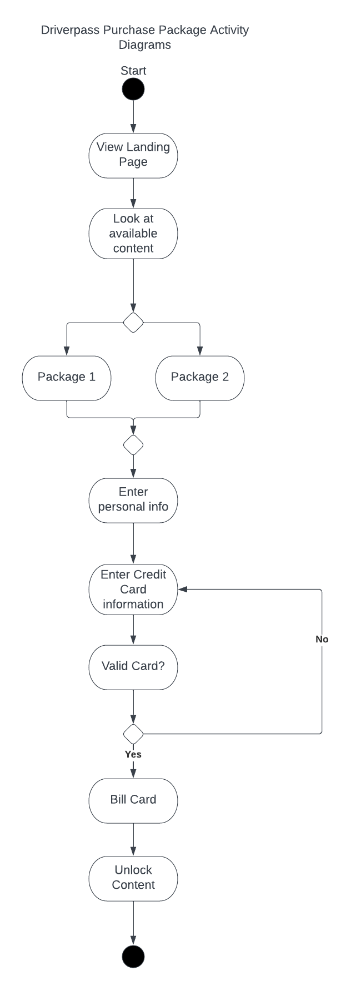

### UML Sequence Diagram

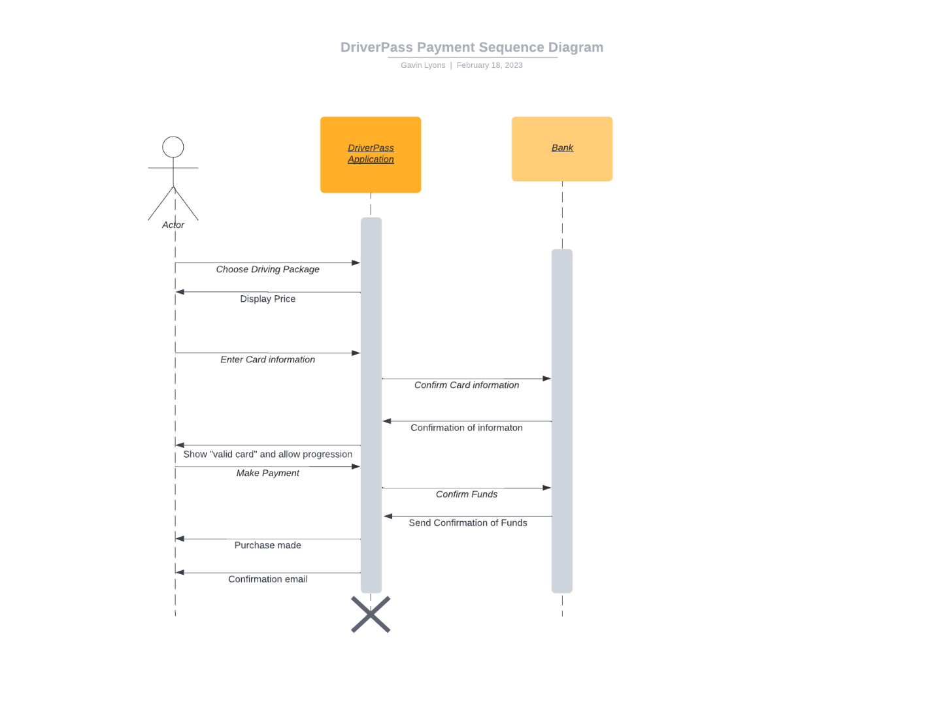

### UML Class Diagram

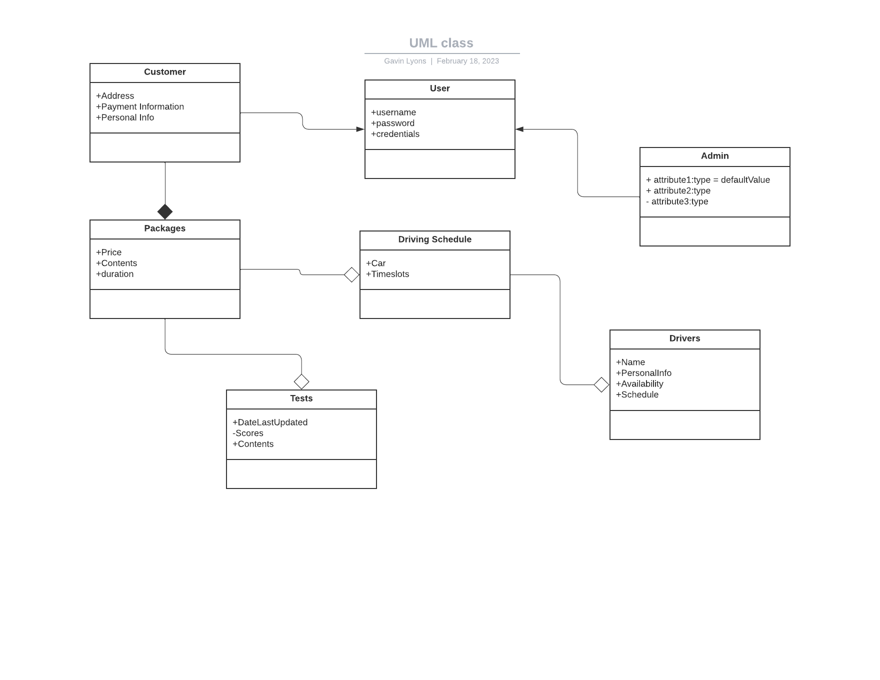

## Technical Requirements

Hardware:

* + Cloud Servers
    - include a backup and test server
  + Devices capable of using application interface for administrator access

Software:

* Security software to protect user data
* Internet access
* Driverpass Application

Tools:

* Development tools should be whatever we choose as the development suite. Example Visual Studio Professional
* Network Security tools to monitor traffic

Infrastructure:

* + Server Location
  + Highspeed internet
  + Competent Administrators
  + Good DMV communication streams